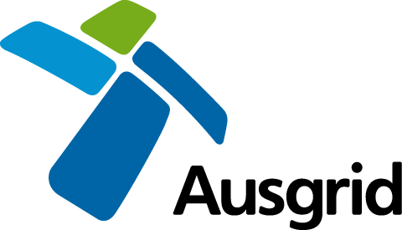

AUSGRID NOTIFICATION TO NPWS OF INSPECTION WORK

This form is to be used to provide notice by or on behalf of Ausgrid to National Parks and Wildlife Services (NPWS) of proposed inspection works in lands reserved or acquired under the National Parks and Wildlife Act 1974.
Note: 4 days prior notification is required before undertaking inspections works (excluding inspections undertaken by foot or passenger vehicle and don’t require the use of equipment).
DESCRIPTION, LOCATION AND DATES OF PROPOSED WORKS
Describe the location of the proposed work and dates (inclusive).
Location:
(Include map)
Dates:
 | (starting date) |  |  |  | (ending date)
Description of works: | Include details of planned inspection works, machinery to be used, access arrangements, vegetation impacts, soil disturbance, proximity to watercourses and if any environmental controls to be implemented.
AUSGRID CERTIFICATION
I have read and certify that the proposed works will comply with the terms of the National Parks Protocol that commenced 1 November 2016.
Ausgrid Representative Name:
Company Name:
Signature:
Phone:
 |  | (work) |  | (after hours)

